JOEY LOGANO WINS CAN-AM 500 AT PHOENIX INTERNATIONAL RACEWAY,
EARNS HIS WAY INTO SPRINT CUP CHAMPIONSHIP RACE THIS WEEKEND

Logano Joins Fellow Wiley X®-Sponsored Driver Carl Edwards As Two Of Four Drivers
Vying to Be Crowned 2016 Champion

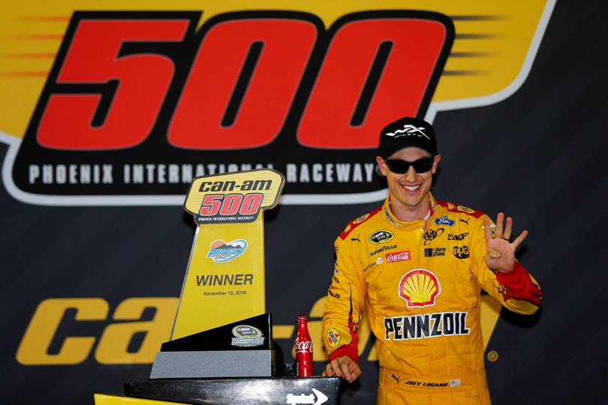
Wiley X®-sponsored NASCAR driver Joey Logano continued his groundbreaking season on November 13, winning what could be the most important Sprint Cup victory of his relatively young career. By winning the Can-Am 500 Sunday at Phoenix International Raceway, Logano earned his way into the Sprint Cup Championship race in Florida this weekend.

There, four drivers will face off at Homestead-Miami Speedway with the chance to be crowned 2016 NASCAR Sprint Cup Champion. Among those battling with Logano for the title will be Carl Edwards, another leading driver who has a long relationship with Wiley X eyewear. This gives Wiley X two sponsored drivers in the final four, an impressive accomplishment and testimony to the caliber of racing professionals the leading eyewear innovator aligns itself with.

“After a long racing season, it all boils down to this one race to crown a champion,” said Wiley X Co-Owner and avid NASCAR enthusiast Myles Freeman, Jr. “This is one of the most exciting events in sports, and it will be even more thrilling for us because we have two members of ‘Team Wiley X’ competing for the title. Whoever wins, we couldn’t be prouder of Joey, Carl and the rest of our drivers for the way they battled and competed over the long, grueling NASCAR Sprint Cup season. We can’t wait to see how it all turns out,” added Freeman.

Logano’s final-four-clinching victory at Phoenix didn’t come easy. The final laps of the race were filled with action and drama, as driver Matt Kenseth (also sponsored by Wiley X) was leading the field after a double-overtime restart with just two laps remaining. Entering Turn 1, Kenseth made contact with second-position driver Alex Bowman, sending Kenseth spinning into the outside wall and allowing Logano to grab a lead he wouldn’t relinquish. Entering this race, Kenseth had also been eligible to earn a berth in the championship finale with a victory — showing just how quickly fortunes can change in the exciting world of NASCAR.

Wiley X has enjoyed a great season of racing and strong working relationships with top NASCAR professionals like Logano, Edwards, Kenseth, Kevin Harvick®, Tony Stewart and others. These high-performance athletes rely on Wiley X’s crystal-clear vision and Absolute Premium Protection both on the track and in their everyday lives. Every adult sunglass style made by Wiley X meets ANSI Z87.1 High Velocity and High Mass Impact Safety Standards, for protection that goes far beyond the harmful rays of the sun. Several styles also meet U.S. military MIL-PRF-32432 (GL) standards for ballistic eye protection, a key reason why the Wiley X has been a leading provider of vision protection equipment to the U.S. military and law enforcement for more than 25 years.

To follow all the action as Wiley X sponsored drivers race towards the 2016 championship crown — or get more information about Wiley X’s complete line of innovative eyewear products providing wearers with Absolute Premium Protection — visit www.wileyx.com. Or contact Wiley X at 7800 Patterson Pass Road, Livermore, CA 94550 • Telephone: (800) 776-7842.

Editor’s Note: For hi-res images and releases, please visit our online Press Room at www.full-throttlecommunications.com.

